How to...

Applicable Releases:
SAP HANA 1.0 SP04
Data Services 4.1

Version 1.0
August 2012

© Copyright 2012 SAP AG. All rights reserved.  No part of this publication may be reproduced or transmitted in any form or for any purpose without the express permission of SAP AG. The information contained herein may be changed without prior notice.  Some software products marketed by SAP AG and its distributors contain proprietary software components of other software vendors.  Microsoft, Windows, Excel, Outlook, and PowerPoint are registered trademarks of Microsoft Corporation.  IBM, DB2, DB2 Universal Database, System i, System i5, System p, System p5, System x, System z, System z10, System z9, z10, z9, iSeries, pSeries, xSeries, zSeries, eServer, z/VM, z/OS, i5/OS, S/390, OS/390, OS/400, AS/400, S/390 Parallel Enterprise Server, PowerVM, Power Architecture, POWER6+, POWER6, POWER5+, POWER5, POWER, OpenPower, PowerPC, BatchPipes, BladeCenter, System Storage, GPFS, HACMP, RETAIN, DB2 Connect, RACF, Redbooks, OS/2, Parallel Sysplex, MVS/ESA, AIX, Intelligent Miner, WebSphere, Netfinity, Tivoli and Informix are trademarks or registered trademarks of IBM Corporation.  Linux is the registered trademark of Linus Torvalds in the U.S. and other countries.  Adobe, the Adobe logo, Acrobat, PostScript, and Reader are either trademarks or registered trademarks of Adobe Systems Incorporated in the United States and/or other countries.  Oracle is a registered trademark of Oracle Corporation.  UNIX, X/Open, OSF/1, and Motif are registered trademarks of the Open Group.  Citrix, ICA, Program Neighborhood, MetaFrame, WinFrame, VideoFrame, and MultiWin are trademarks or registered trademarks of Citrix Systems, Inc.  HTML, XML, XHTML and W3C are trademarks or registered trademarks of W3C®, World Wide Web Consortium, Massachusetts Institute of Technology.  Java is a registered trademark of Sun Microsystems, Inc.  JavaScript is a registered trademark of Sun Microsystems, Inc., used under license for technology invented and implemented by Netscape.  SAP, R/3, SAP NetWeaver, Duet, PartnerEdge, ByDesign, SAP BusinessObjects Explorer, StreamWork, and other SAP products and services mentioned herein as well as their respective logos are trademarks or registered trademarks of SAP AG in Germany and other countries.  Business Objects and the Business Objects logo, BusinessObjects, Crystal Reports, Crystal Decisions, Web Intelligence, Xcelsius, and other Business Objects products and services mentioned herein as well as their respective logos are trademarks or registered trademarks of Business Objects Software Ltd. Business Objects is an SAP company.  Sybase and Adaptive Server, iAnywhere, Sybase 365, SQL Anywhere, and other Sybase products and services mentioned herein as well as their respective logos are trademarks or registered trademarks of Sybase, Inc. Sybase is an SAP company. | All other product and service names mentioned are the trademarks of their respective companies. Data contained in this document serves informational purposes only. National product specifications may vary.  The information in this document is proprietary to SAP. No part of this document may be reproduced, copied, or transmitted in any form or for any purpose without the express prior written permission of SAP AG.  This document is a preliminary version and not subject to your license agreement or any other agreement with SAP. This document contains only intended strategies, developments, and functionalities of the SAP® product and is not intended to be binding upon SAP to any particular course of business, product strategy, and/or development. Please note that this document is subject to change and may be changed by SAP at any time without notice.  SAP assumes no responsibility for errors or omissions in this document. SAP does not warrant the accuracy or completeness of the information, text, graphics, links, or other items contained within this material. This document is provided without a warranty of any kind, either express or implied, including but not limited to the implied warranties of merchantability, fitness for a particular purpose, or non-infringement.  SAP shall have no liability for damages of any kind including without limitation direct, special, indirect, or consequential damages that may result from the use of these materials. This limitation shall not apply in cases of intent or gross negligence.  The statutory liability for personal injury and defective products is not affected. SAP has no control over the information that you may access through the use of hot links contained in these materials and does not endorse your use of third-party Web pages nor provide any warranty whatsoever relating to third-party Web pages.  SAP “How-to” Guides are intended to simplify the product implementtation. While specific product features and procedures typically are explained in a practical business context, it is not implied that those features and procedures are the only approach in solving a specific business problem using SAP NetWeaver. Should you wish to receive additional information, clarification or support, please refer to SAP Consulting.  Any software coding and/or code lines / strings (“Code”) included in this documentation are only examples and are not intended to be used in a productive system environment. The Code is only intended better explain and visualize the syntax and phrasing rules of certain coding. SAP does not warrant the correctness and completeness of the Code given herein, and SAP shall not be liable for errors or damages caused by the usage of the Code, except if such damages were caused by SAP intentionally or grossly negligent.  Disclaimer  Some components of this product are based on Java™. Any code change in these components may cause unpredictable and severe malfunctions and is therefore expressively prohibited, as is any decompilation of these components.  Any Java™ Source Code delivered with this product is only to be used by SAP’s Support Services and may not be modified or altered in any way.

Document History
Document Version | Description
1.00 | First official release of this guide

Typographic Conventions
Type Style | Description
Example Text | Words or characters quoted from the screen. These include field names, screen titles, pushbuttons labels, menu names, menu paths, and menu options.  Cross-references to other documentation
Example text | Emphasized words or phrases in body text, graphic titles, and table titles
Example text | File and directory names and their paths, messages, names of variables and parameters, source text, and names of installation, upgrade and database tools.
Example text | User entry texts. These are words or characters that you enter in the system exactly as they appear in the documentation.
<Example text> | Variable user entry. Angle brackets indicate that you replace these words and characters with appropriate entries to make entries in the system.
EXAMPLE TEXT | Keys on the keyboard, for example, F2 or ENTER.
Icons
Icon | Description
 | Caution
 | Note or Important
 | Example
 | Recommendation or Tip

Table of Contents

1. Introduction 1
2. Prerequisites 1
3. Invoking a simple stored procedure 1
3.1 Create database objects 2
3.2 Import Stored Procedure Metadata 4
3.3 Invoke the Procedure 6
4. Error Handling 7
5. Stored Procedures with Table Parameters 9
6. Calling a Stored Procedure via SQL SELECT 13
7. Additional Information 16
8. Appendix 17

Introduction

With SAP HANA, logic is often written in stored procedures as they give various advantages over writing plain SQL.

- They are pre-compiled which gives a performance gain
- Complex logic can be encapsulated in an easy to consume form
- They support writing logic in various languages
- Certain features are only supported in stored procedures (CE functions for example)

Data Services has support for HANA stored procedures. This document shows how to invoke HANA stored procedures with various signatures.

Prerequisites

To build the examples presented in this how-to guide the reader will require the following software. Knowledge of using the software is expected.

Server - HANA
- HANA 1.0 SP04 (release 33 was used to build the examples)

Server - Data Services
- Data Services 4.1
- HANA 1.0 SP04 (release 33) 64 bit client

Client-side
- HANA 1.0 SP04 (release 33) client*
- HANA 1.0 SP04 (release 33) Studio
- Data Services 4.1 Designer*

* Data Services 4.1 Designer is available as 32 or 64 bit, use the matching HANA client.

Invoking a simple stored procedure

This section invokes a simple stored procedure that multiplies 2 numbers together and returns the result. It is assumed that connectivity between Data Services and HANA has already been configured (including the creation of a datastore).

Before we start, a description of how HANA handles the case of database object names would be useful. HANA database object names are case sensitive; however the case is only enforced if the object names are surrounded by double quotes. If object names are not surrounded by double quotes HANA converts them to uppercase. This can lead to confusion, for example when creating an object using lowercase without double quotes the object name becomes uppercase. All HANA SYSTEM objects are uppercase, and I would suggest following this convention. This means that when writing SQL any case can used without using double quotes; see below for some examples.

select dummy from sys.dummy; ok
select DUMMY from SYS.DUMMY; ok
select dUMMy from sYs.dUMMy; ok
select "DUMMY" from "SYS"."DUMMY"; ok
select "dummy" from "sys"."dummy"; not ok

The examples provided in this document all use lowercase and no quotes, meaning all objects are actually uppercase. The HANA Studio displays objects with their correct case.

Create database objects

It is assumed that a HANA database user is already created and a HANA system already configured in the studio.

In the HANA studio with the modeller perpective open, open a new SQL Editor window.

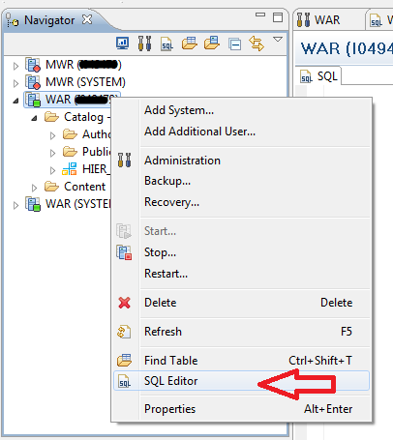

The following script will create a new schema and sample objects. Either copy and paste the script, or use the script attached in the Appendix. Execute the script to create all the sample database content. You do not need to understand the content, it is explained throughtout the examples.

/* script to create database objects for stored procedure demo */

create schema sp_demo;

/* simple procedure with in and out scalar parameters
(the poor choice of output datatype is intentional) */

create procedure sp_demo.multiply(in factor1 int, in factor2 int, out product int)
language sqlscript as
begin
product := :factor1 * :factor2;
end;

/* table type to define input and output structure
for the following stored procedure */

create type sp_demo.tt_number as table (number int);

/* simple procedure with in and out table parameters */

create procedure sp_demo.number_split(
in all_numbers sp_demo.tt_number,
out odd_numbers sp_demo.tt_number,
out even_numbers sp_demo.tt_number)
language sqlscript as
begin
odd_numbers = select number from :all_numbers where mod(number, 2) = 1;
even_numbers = select number from :all_numbers where mod(number, 2) = 0;
end;

/* wrapper stored procedure and supporting objects */

create column table sp_demo.number_input(number int);
create column table sp_demo.number_odd(number int);
create column table sp_demo.number_even(number int);

create procedure sp_demo.wrap_number_split
language sqlscript as
begin
number_input = select number from sp_demo.number_input;
odd = select 1 as number from sys.dummy where 1 = 0;
even = select 1 as number from sys.dummy where 1 = 0;
call sp_demo.number_split(:number_input, :odd, :even);

insert into sp_demo.number_odd (select number from :odd);
insert into sp_demo.number_even (select number from :even);
end;

/* simple stored procedure that can be invoked using a sql select */

create procedure sp_demo.display_result(
in number_type varchar(4),
out number_set sp_demo.tt_number)
language sqlscript reads sql data with result view number_view as
begin
if :number_type = 'odd' then
number_set = select number from sp_demo.number_odd;
else
number_set = select number from sp_demo.number_even;
end if;
end;

/* uncomment the following line to remove all the sp_demo database objects */
--drop schema sp_demo cascade;

/* case sensitivity demo */

--select dummy from sys.dummy; ok
--select DUMMY from SYS.DUMMY; ok
--select dUMMy from sYs.dUMMy; ok
--select "DUMMY" from "SYS"."DUMMY"; ok
--select "dummy" from "sys"."dummy"; not ok

Import Stored Procedure Metadata

The procedure we are going to invoke has the following definition. It has 2 input parameters and 1 output parameter. The parameters are all scalar.

create procedure sp_demo.multiply(in factor1 int, in factor2 int,
out product int)
language sqlscript as
begin
product := :factor1 * :factor2;
end;

To import the metadata - in the Data Services Designer right-click on your HANA datastore and select Import By Name… from the context menu.

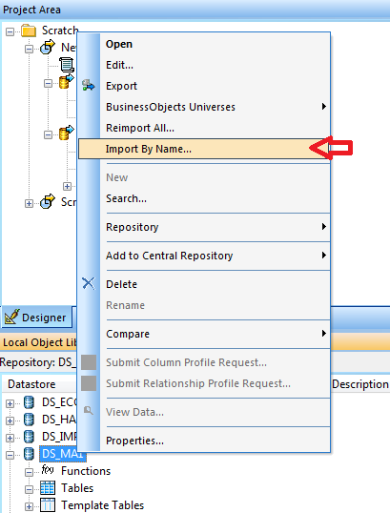

In the Import By Name dialog select Type as Function, Name as multiply and Owner as sp_demo. Click Import.

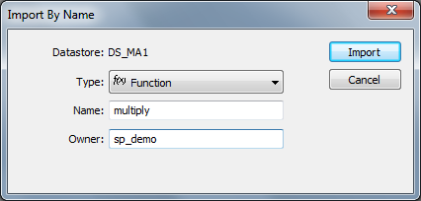

Data Services displays the name of the imported procedure under Functions in the datastore.
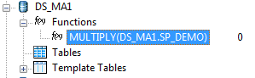

Double-clicking on the procedure name displays the signature; showing the input and output parameters and their datatype. Ignore the 2 AL_SP_ parameters; they are covered in the next section.

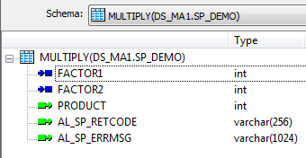

Invoke the Procedure

To invoke the procedure create a new batch job containing a single script. Define a variable to be used for capturing the output from the procedure. I created a local variable and called it $L_Product, the Data type should match the procedure’s output parameter type.

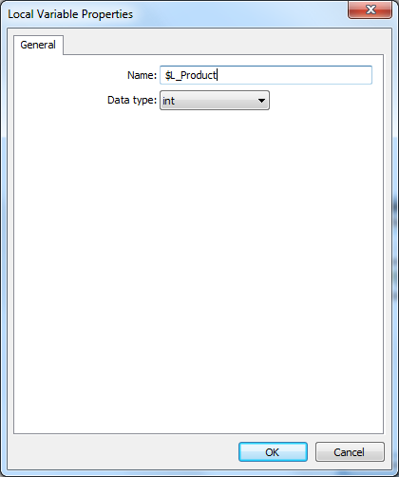

My script was defined as follows (amend datastore and variable names as appropriate). It is possible to drag the procedure name from the datastore into the script.

DS_MA1.SP_DEMO.MULTIPLY(2, 3, $L_Product);
print('Product: [$L_Product]');

The first line invokes the procedure using constant values 2 and 3 and the variable $L_Product as arguments. The procedure will assign the result to the variable $L_Product. The second line prints the result of the call to the trace log.

Executing this job produces the following output.

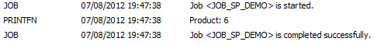

The procedure was successfully invoked.

Error Handling

Using the same example as the previous section, try changing the constant arguments to 3000 (three thousand) and 1000000 (one million) and executing the job.

The execution fails with a numeric overflow exception raised from HANA.

This is expected as the output parameter has been incorrectly defined as an INT datatype. This was on purpose.

To trap an exception that is raised within a procedure call we can use either the try/catch mechanism that Data Services provides, or the special return parameters that Data Services add to the procedure metadata.

To use the try/catch modify the script as shown below

try
begin
DS_MA1.SP_DEMO.MULTIPLY(3000, 1000000, $L_Product);
print('Product: [$L_Product]');
end
catch ( ALL )
begin
print('An exception occurred.');
end

Now when we execute the job the exception is caught and we can perform some alternative action.

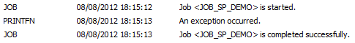

This mechanism does not provide details that allow us to make decisions based on the error. Using the special parameters that Data Services appends to the procedure we have more data to make decisions.

Define 2 new variables in your job for the output parameters.

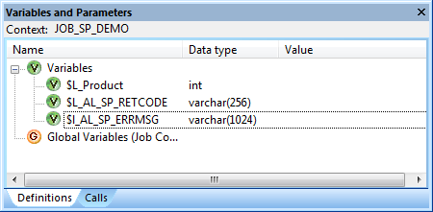

Modify your script as shown below and execute the job.

DS_MA1.SP_DEMO.MULTIPLY(3000, 1000000, $L_Product, $L_AL_SP_RETCODE, $L_AL_SP_ERRMSG);
print('Product: [$L_Product]');

if ($L_AL_SP_RETCODE = 'ACTA_SP_CALL_ERROR')
print('$L_AL_SP_ERRMSG: [$L_AL_SP_ERRMSG]');
Whilst in the example we are only printing the error, we could easily parse the error message to get more details.

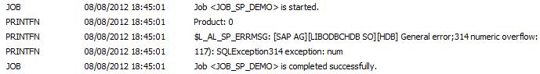

Stored Procedures with Table Parameters

HANA stored procedures can define scalar (integer, varchar, date, etc.) or table type parameters. The script in section 1 created a stored procedure with 3 table type parameters and the definition of the table type used, the definition is shown below.

create type sp_demo.tt_number as table (number int);

create procedure sp_demo.number_split(
in all_numbers sp_demo.tt_number,
out odd_numbers sp_demo.tt_number,
out even_numbers sp_demo.tt_number)
language sqlscript as
begin
odd_numbers = select number from :all_numbers where mod(number, 2) = 1;
even_numbers = select number from :all_numbers where mod(number, 2) = 0;
end;

The sample procedure accepts a set of numbers are returns 2 sets, one containing odd numbers from the input set and one containing even numbers.

Try importing the metadata for this procedure.

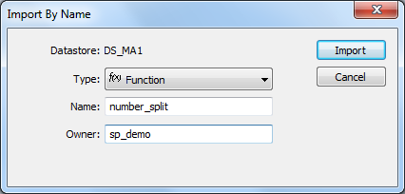

Data Services imports the metadata, but gives us a warning saying that the table type parameters have been omitted.

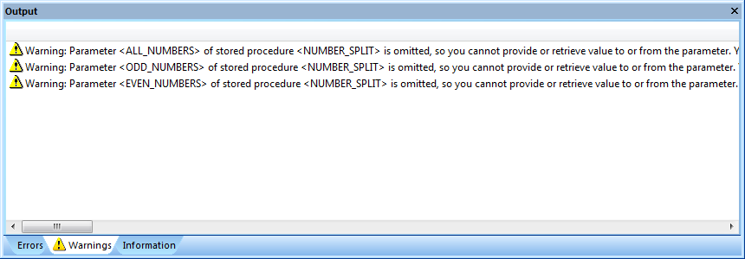

This is as expected as the Data Services documentation states that table type parameters are not supported. So, we can’t call this procedure from Data Services, but what if it is crucial to our implementation to call a procedure with table type parameters? The answer is simple, we can create a simple wrapper stored procedure and some interface tables.

The script above created the following database objects.

create column table sp_demo.number_input(number int);
create column table sp_demo.number_odd(number int);
create column table sp_demo.number_even(number int);

create procedure sp_demo.wrap_number_split
language sqlscript as
begin
number_input = select number from sp_demo.number_input;
odd = select 1 as number from sys.dummy where 1 = 0;
even = select 1 as number from sys.dummy where 1 = 0;

call sp_demo.number_split(:number_input, :odd, :even);

insert into sp_demo.number_odd (select number from :odd);
insert into sp_demo.number_even (select number from :even);
end;

The 3 tables are the interface tables and the procedure wraps the call to the stored procedure with the table type parameters.

Create a new job with a single dataflow followed by a script.

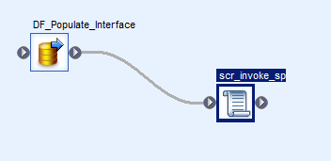

Import the metadata for the input interface table – sp_demo.number_input and the wrapper stored procedure – sp_demo.wrap_number_split.

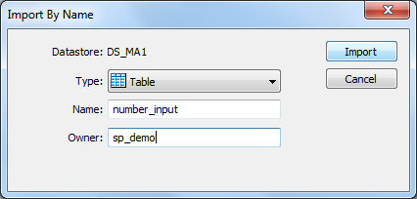

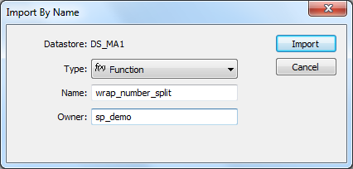

In the dataflow use a row generation as the source and populate the interface table with 99 numbers starting from 1. Truncate the target table before loading.
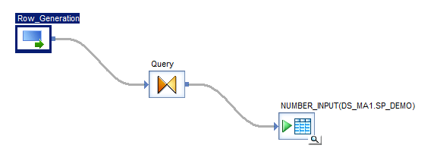

Define the script as follows.

sql('DS_MA1', 'truncate table sp_demo.number_odd');
sql('DS_MA1', 'truncate table sp_demo.number_even');

print('Input interface table row count: ' || sql('DS_MA1', 'select count(*) from sp_demo.number_input'));

DS_MA1.SP_DEMO.WRAP_NUMBER_SPLIT();

print('Output Interface table (odd) row count: ' || sql('DS_MA1', 'select count(*) from sp_demo.number_odd'));
print('Output Interface table (odd) min value: ' || sql('DS_MA1', 'select min(number) from sp_demo.number_odd'));
print('Output Interface table (odd) max value: ' || sql('DS_MA1', 'select max(number) from sp_demo.number_odd'));

print('Output Interface table (even) row count: ' || sql('DS_MA1', 'select count(*) from sp_demo.number_even'));
print('Output Interface table (even) min value: ' || sql('DS_MA1', 'select min(number) from sp_demo.number_even'));
print('Output Interface table (even) max value: ' || sql('DS_MA1', 'select max(number) from sp_demo.number_even'));

Execute the job.

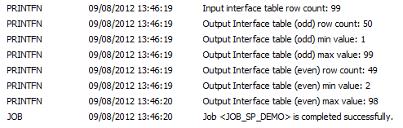

The job invokes the interface and the desired logic is executed successfully.

Calling a Stored Procedure via SQL SELECT

With HANA it is possible to define a stored procedure in such a way so that it can be invoked as if it is a table or view in a SQL SELECT statement. There are some semantic constraints that must be followed, but basically the procedure must not modify the database state and have one output table parameter.

The script above defined a stored procedure that followed the convention.

create procedure sp_demo.display_result(
in number_type varchar(4),
out number_set sp_demo.tt_number)
language sqlscript reads sql data with result view number_view as
begin
if :number_type = 'odd' then
number_set = select number from sp_demo.number_odd;
else
number_set = select number from sp_demo.number_even;
end if;
end;

The procedure accepts a string (‘odd’ or another string that is not ‘odd’) and returns either the contents of sp_demo.number_odd or sp_demo.number_even from the previous exercise.

The procedure can executed using the call syntax or in a select statement. Execute the following statements (separately) in the HANA Studio.

call sp_demo.display_result('even', ?);
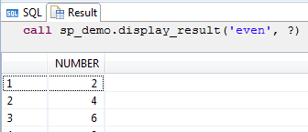

select * from sp_demo.number_view
with parameters ('placeholder' = ('$$number_type$$', 'odd'))

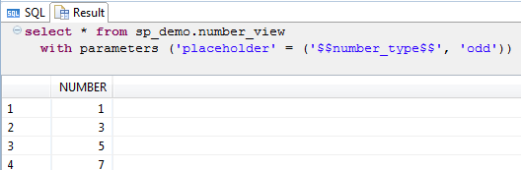

To execute this procedure in Data Services we can use the SQL transform.

Create a job that contains a script followed by a dataflow.

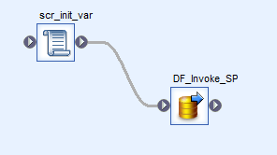

Define a global variable to parameterize the SQL transform to pass a variable to the stored procedure input value.
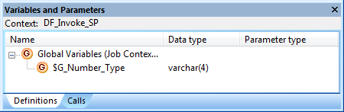

In the dataflow add a SQL transform and a template table.
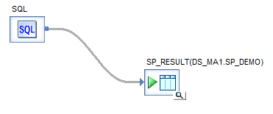
In the SQL transform editor paste in the following SQL Text and click Update Schema.

select * from sp_demo.number_view
with parameters ('placeholder' = ('$$number_type$$', '[$G_Number_Type]'))

Define the script as follows.

$G_Number_Type = 'even';

Execute the job and view the data in the template table.

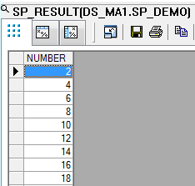

Change the script and re-execute the job.

$G_Number_Type = 'odd';

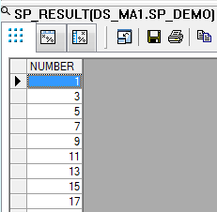

Additional Information

All the material covered in this how-to guide is from the following SAP documentation.

How to call procedures is covered in the Data Services Reference Guide.
http://help.sap.com/businessobject/product_guides/sboDS41/en/sbo41_ds_reference_en.pdf

The full set of Data Services documentation
http://help.sap.com/bods

How to create HANA Stored Procedures is covered in the SQLScript Guide
http://help.sap.com/hana/hana_dev_sqlscript_en.pdf

The full set of HANA Documentation
http://help.sap.com/hana

Appendix

Appendix A - Database object creation DDL

